**22.Write a c program to implement array using stack operation.**

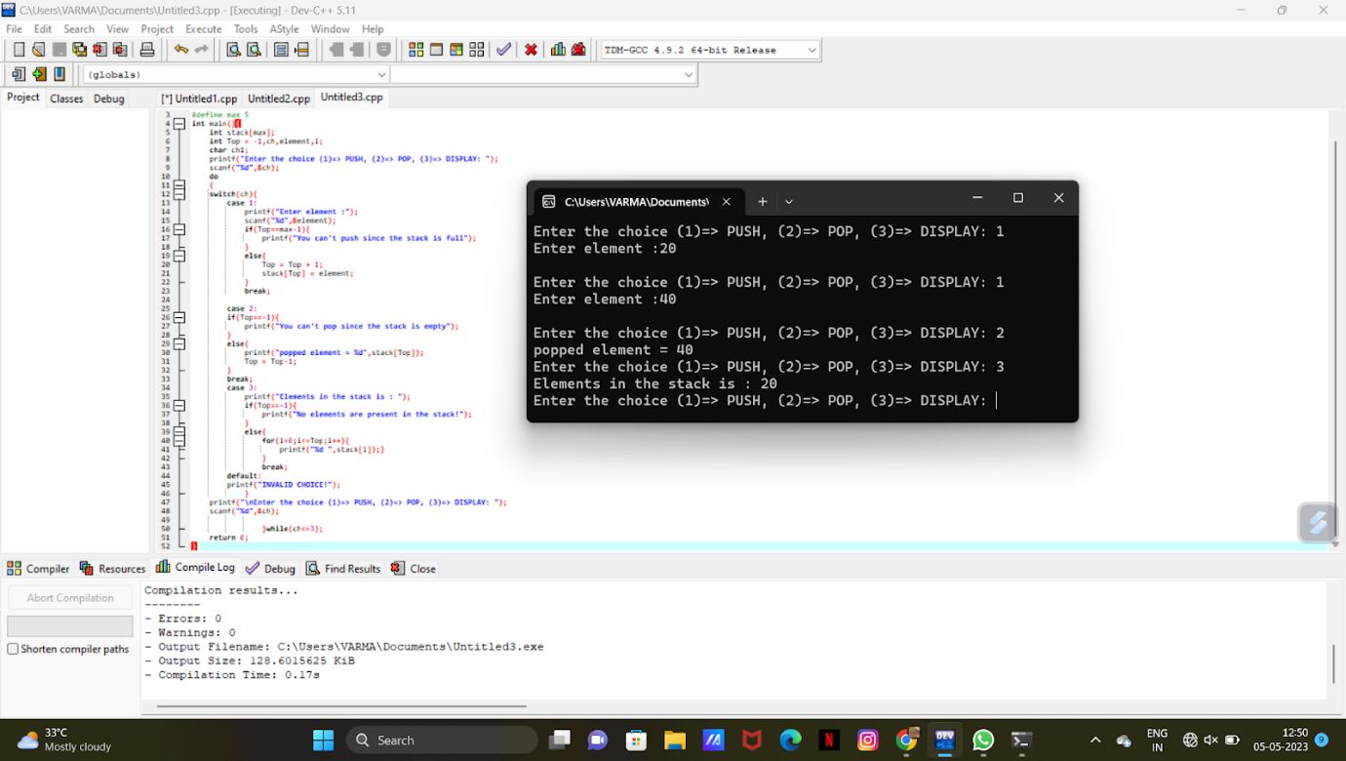

**23. To implement QUEUE operation data strcture using c program**

